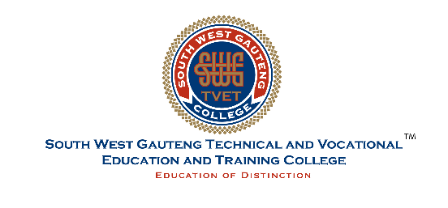

INTERNAL ADVERT

South West Gauteng College hereby requests applications from prospective candidates for the following Temporal post based at the Molapo Campus.
Job Title: Temporal Lecturer: Welding L2- L4 NC(V)& Engineering Fundamentals
MOL/WEF/2025
Minimum Requirements:
- A recognized 3-year Degree/Diploma with (TRADE TEST) qualification with majors in the particular field of study and In-depth knowledge of the subject.
- Registration with SACE (South African Council of Educators) will be an added advantage.
- Excellent communication in English (written and verbal), organizing, planning, and administration skills.
Duties and responsibilities:
Facilitate the general academic and career development of students. Prepare lesson plans and lecture students in compliance with the College Annual Academic Plan, the Campus timetable, and the College Quality Management System. Assess students, maintain assessment records, and capture marks electronically in compliance with the College’s policies and procedures. Create a conducive classroom environment and ensure efficient classroom management and discipline of students. Report to the Senior Lecturer and liaise with the Student Support Officers in providing support interventions to students. Prepare academic materials and distribute student packs to students and maintain the necessary records. Manage and monitor student attendance and organize job placement and excursions for students.

Key skills needed:

- Engineering Industry Experience.
- Ability to monitor students’ performance and provide critical feedback objectively and professionally.

NB! Closing: 16 September 2025 @16H00. Applications should be sent at the Head Office and please use NEW Z83. The College reserves the right not to fill the advertised posts. Any applications received after the above mentioned date will not be considered.
Enquires: Mr Thando Khuse & Ms Tsholofelo Letaoana
Tel: 010 141 1000 at EXT 1032, respectively
Note: All costs incurred due to your application and interviews will be at your own expense.
Applications for the above positions should be hand delivered or posted to the address below:
South West Gauteng TVET College | 1822a Molele Street | Cnr Koma Road, Molapo | Soweto

